

**Faculty of Engineering and Technology**

**Electrical and Computer Engineering**

**Department**

**Communication Laboratory**

**ENEE4113**

**Prelab Exp1 Normal Amplitude Modulation**

**and Demodulaiton**

**Prepared by:**

Arwa Doha 11906324

**Instructor:** Dr.Ashraf Rimawi

**Assistant:** Eng.Mohammed Battat

**Section:** 6

**Date:** October 4, 2023

**Software Prelab (Simulink Matlab):**

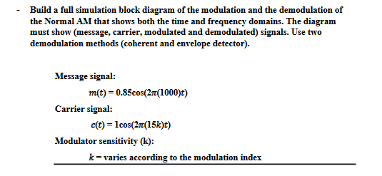

The demodulated signal = Ac` [ 1+μ cos(ωmt)].

So: Am=0.85 / Fm=1000

Ac=1 / Fc=15000

Normal Amplitude Modulation

* Modulation Index 🡪 μ=KaAm
* The modulated signal 🡪 S(t) = Ac [1 + ka * m(t)] * Cos(2 * π * fm * t)
* According to what is given:
* The message signal 🡪 m(t) = 0.85 * Cos(2 * π * 1000 * t)
* The carrier signal 🡪 c(t) = Cos(2 * π * 15k * t)
* Therefore S(t) = 1 * [1 + ka * 0.85 * Cos(2 * π * 1000 * t)] * Cos(2 * π * 15k * t)
* Modulation of normal AM block diagram:

Time domain:

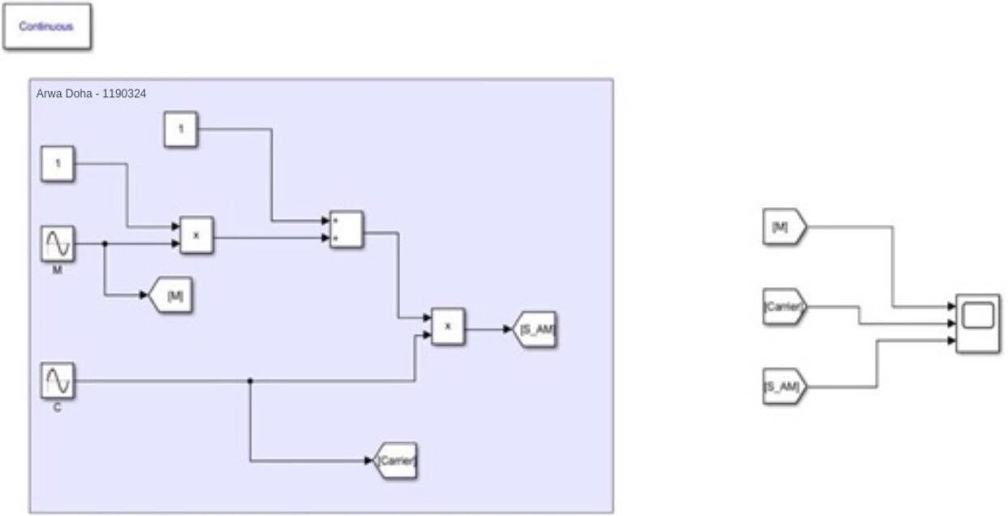

*Fig1: Normal AM block in time domain*

Frequency Domain:

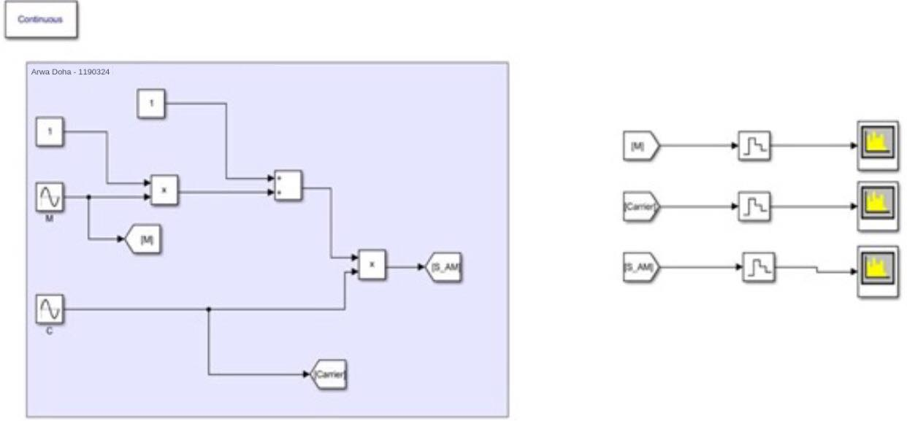

*Fig2: Normal AM block in frequency domain*

In Time domain:

1. m(t):Massage signal
2. c(t):Carrier signal
3. s(t):Modulated signal

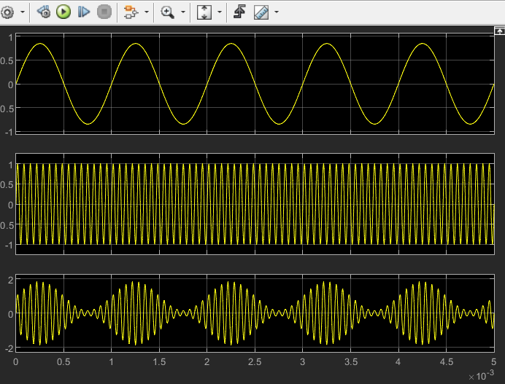

*Fig3: In time domin m(t)/c(t)/s(t)*

As depicted in the above figure, the amplitude of the modulated signal varies according to the expression Ac[1 + ka * m(t)]. To compute the modulation index, we can use the formula:

Modulation Index = (Amax - Amin) / (Amax + Amin)

= (1.425 - 0.575) / (1.425 + 0.575)

= 0.85 / 2

= 0.425.

Since **μ<1**, it falls into the category of under modulation.

In Frequency domain:

* **Massage signal🡪m(t):**

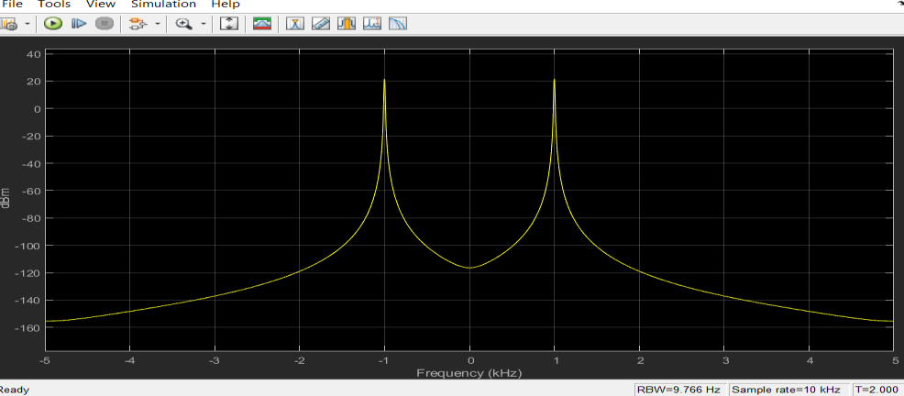

*Fig4: in frequency domain m(t)*

* **Carrier signal🡪c(t):**

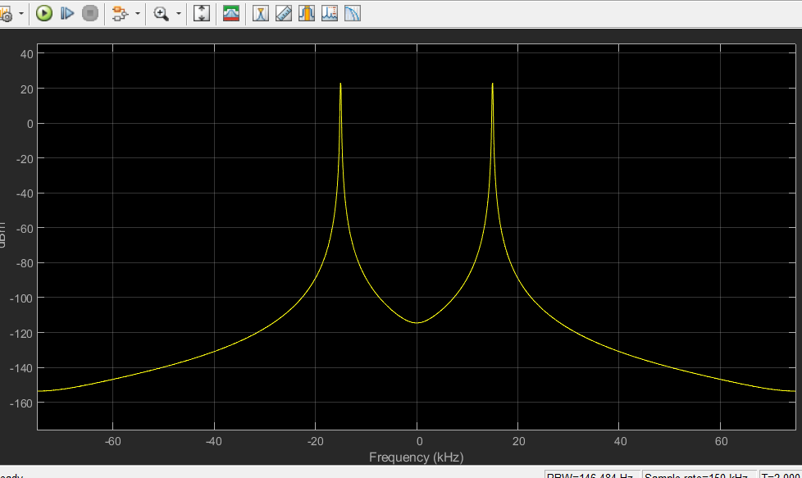

*Fig5: c(t) in frequency domain c(t)*

* Modulated signal🡪S(t):

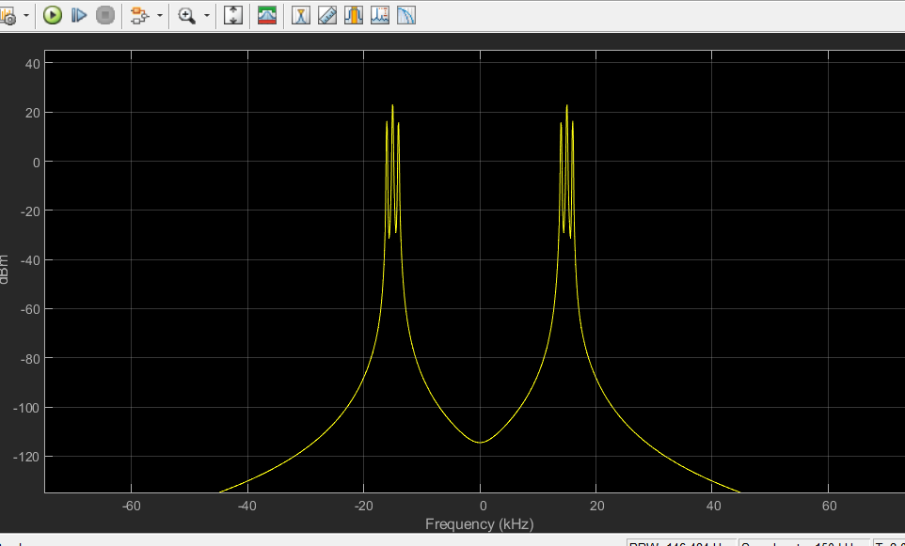

*Fig6: in frequency domain s(t)*

1. When ka==0.590 🡪

Block Diagram

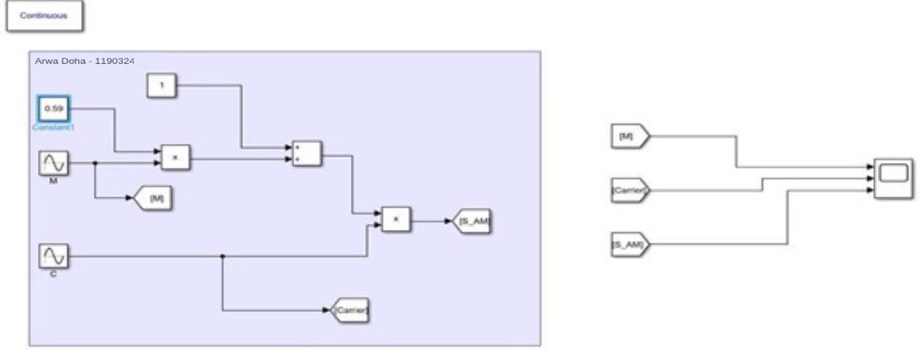

*Fig7: block diagram when k=0.590*

In time domain:

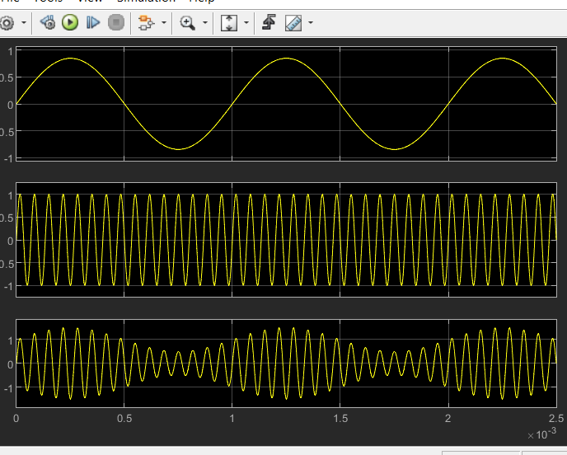

*Fig8: time domain,when k==0.590*

In this scenario, **μ<1** indicates that the carrier amplitude is not fully modulated.

2. When Ka = 1.18 🡪

Block Diagram :

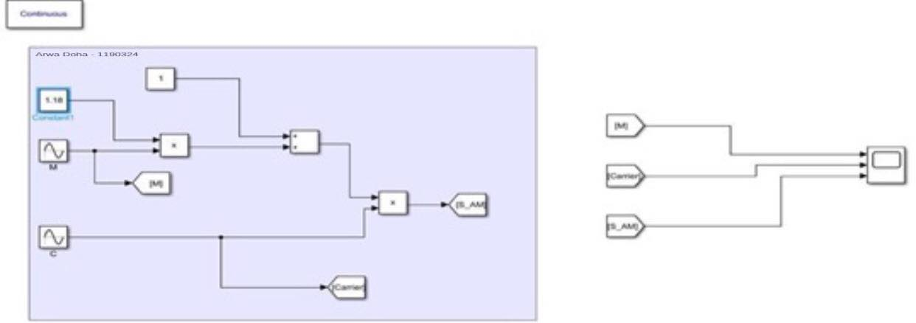

*Fig9: block diagram when k=1.18*

In time domain:

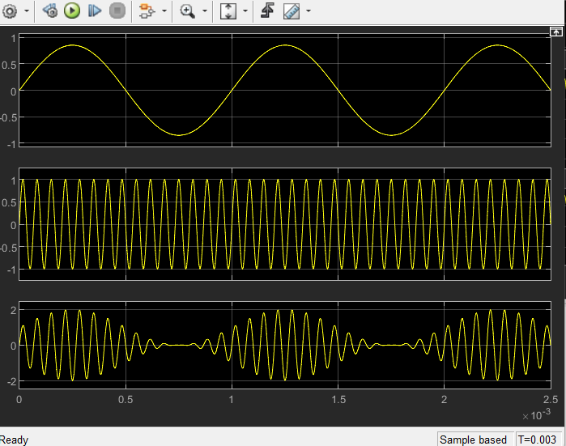

*Fig10: time domain when ka=1.18*

3. When Ka = 2.23 🡪

Block Diagram :

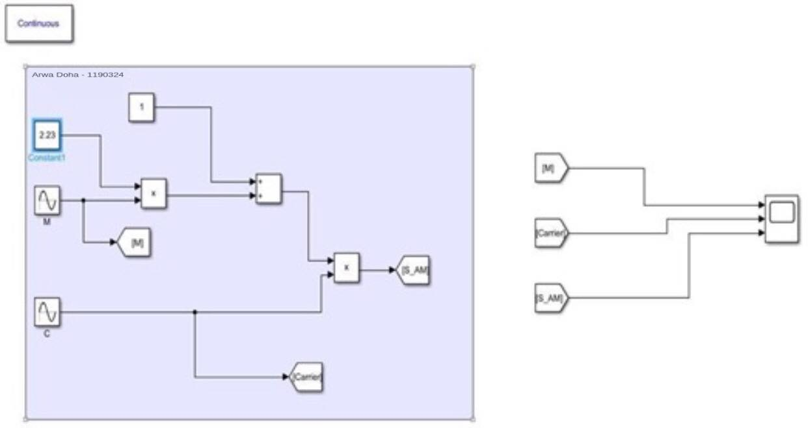

*Fig11: block diagram,when k=2.230*

In time domain:

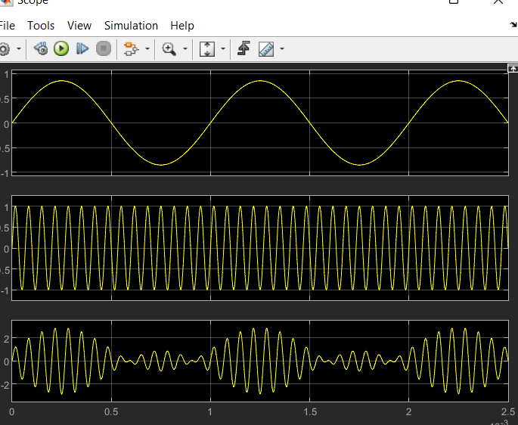

*Fig12: time domain,when ka=2.23*

When the modulation index exceeds 1, it signifies over-modulation of the carrier amplitude.

This can result in signal distortion and the creation of sidebands.

* Coherent Demodulation

Demodulation is achieved by connecting the AM signal from the first half to an analog filter with a cutoff frequency higher than the lowest frequency present in the message signal.

Block of Demodulation :

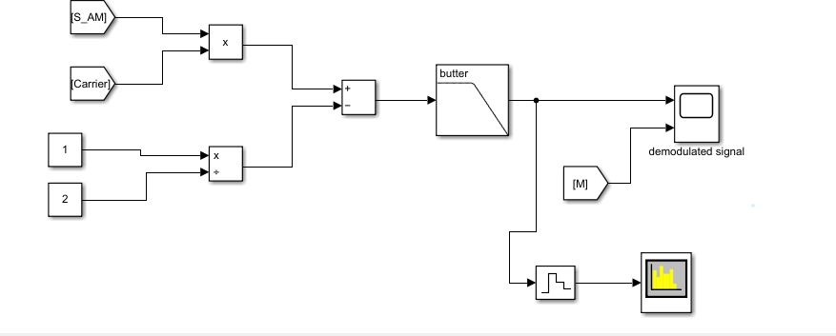

*Fig13: coherent demodulation block*

Show Demodulation Signal and Massage Signal:

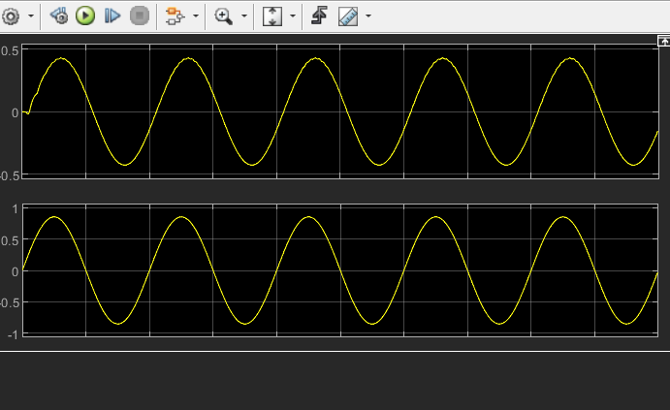

*Fig14: signals of message signal and demodulation signal*

In Spectrum:



*Fig15: result in spectrum*

→ Coherent_Demodulation 🡪when ka=0.590

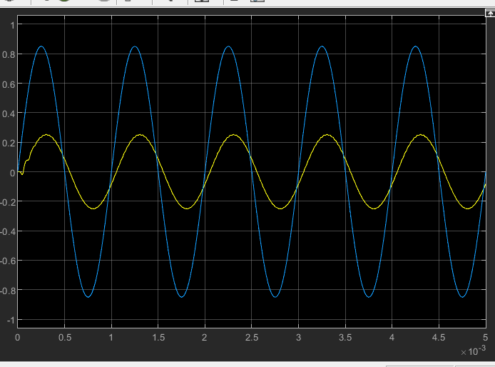

*Fig16: demodulation coherant,when ka=0.590*

The coherent demodulator effectively retrieves the original message signal by multiplying the received signal with a synchronized carrier signal. This process yields a reconstructed message signal in the time domain that closely resembles the original signal.

→ coherent_demodulation_when ka=1.180

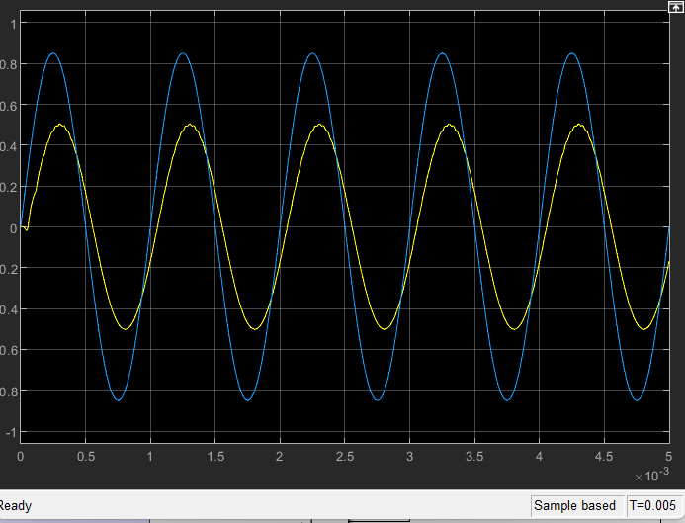

*Fig17: coherentdemodulation,when ka =1.180*

→ coherent demodulation🡪when ka=2.23

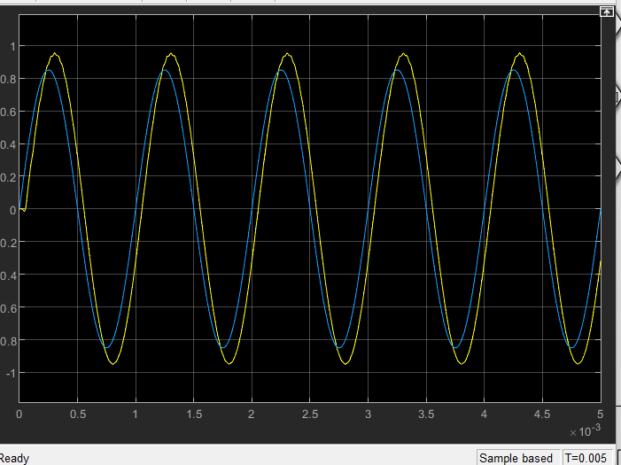

*Fig18: coherent demodulation,when ka =2.23*

The coherent demodulator faces challenges in accurately recovering the original message signal, primarily because of the presence of sidebands. This results in distortion and a noticeable loss of fidelity in the demodulated signal.

* Envelope Demodulation:

Envelope Demodulation block Diagram :

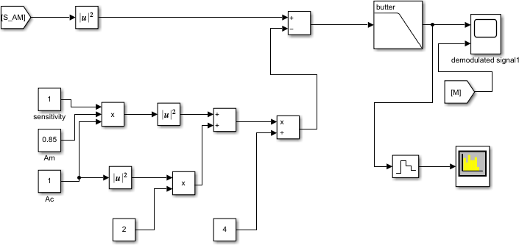

*Fig19 envelope demodulation* *block Diagram*

Demodulation signal and massage Signal:

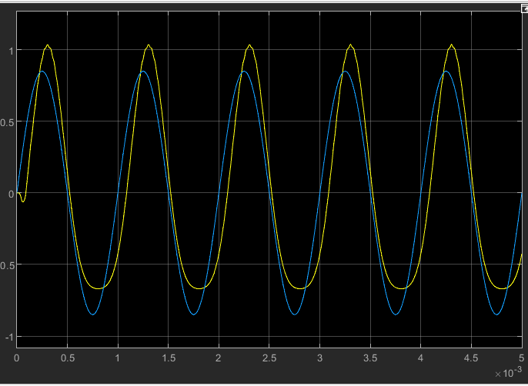

*Fig20: demodulation signal and message signal*

Notice_that_the_message and its demodulated signal are_equally_the same

